Таска1
Uвых
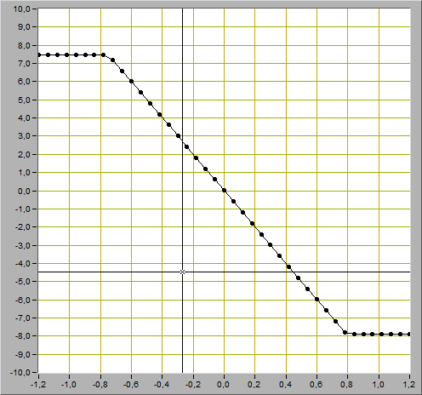Uвх

Uогр-=-7,88В
Uогр+=7.48B

Т2: (0.24;-2,37) Т1:(-0,42; 4,20)

Kyc = 0,66/-6,57=-0,10

Таска2

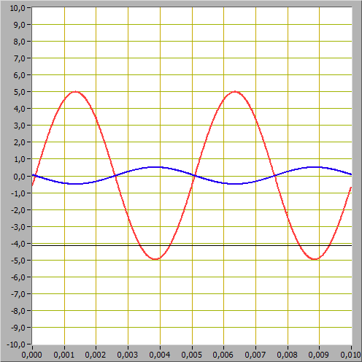
А вых = (5.07 - -5.02)/2 = 5,45В
А вх = (0.58 - -0.54)/2 = 0.56В

К ус = 5,45/0.56 = 9.73
К = Rос/R1 = 100kOm/10kOm = 10

Таска3
Uвых,В
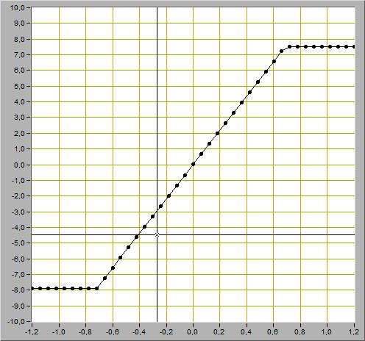Uвх, В
Uогр-=-7,89В
Uогр+= 7,46B

Т1: (-0.43;-4.69) Т2:(0.06;0.72)

Kyc = 5.41/ 0.49= -10.98

Таска4
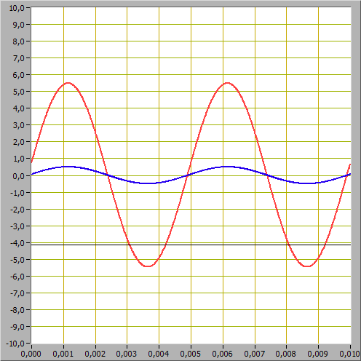
А вых = (5.51 - -5.48)/2 = 5,495В
А вх = (0.59 - -0.53)/2 = 0.56В

К ус = 5,495/0.56 = 9.81

К = 1 + Roc/R1 = 1 + 100kOm/10kOm = 11

Таска5
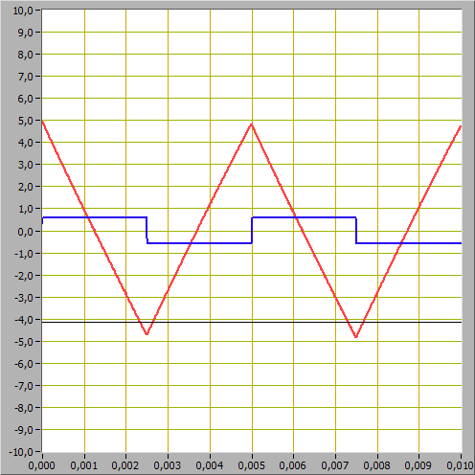
V 1= -2(4.84 - -4.69)/0.005 = -3812
V2 = 0.59B/10kOm/15*10^-9 = 39.33
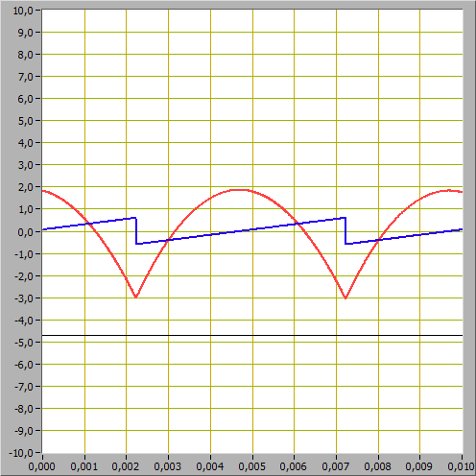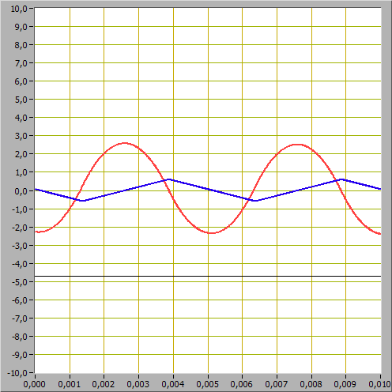
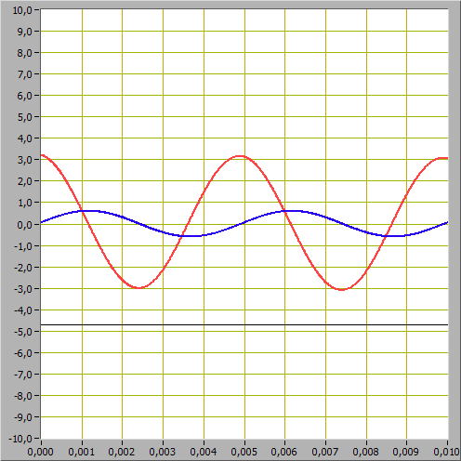
Task6
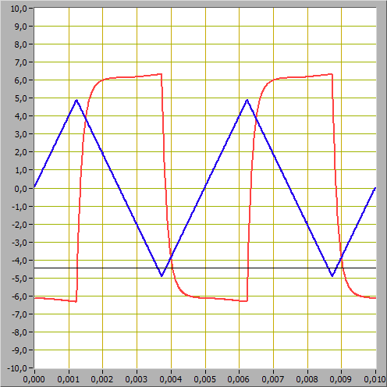

Uвых.т. = (6.38 - - 6.35)/2 = 6.365
Uвх.т. = (4.88--4.93)/2 = 4.905
V1 = 4*4.905/0.005 = 3924
U вых= -100kOm*15*10^-9 * 2/T*(Uвх2 – Uвх1)

